How to order with DVBMarket ?
Firstly please note that :
- DVBMarket selling portfolio to wholesale customers only. You have to own EU VAT ID (IT XXXXXXXXX) if you are from one of EU Countries, if you are not from EU we do not have a problem to export goods anywhere you are.
- Prices on www.dvbmarket.com are without VAT in € (EURO) currency. If you are end customer (private person) or you prefer to buy in USD, feel free to contact us.

If country you are from is not in the list of countries in order menu, contact us !
Order step by step :
Once you choosed which goods do you want to buy from dvbmarket and thinking about quantities feel free to use a roll which is with each product so you will have automaticaly discount for bigger order, in this case 13% OFF !
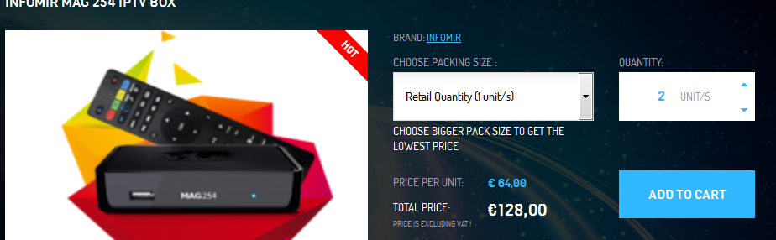
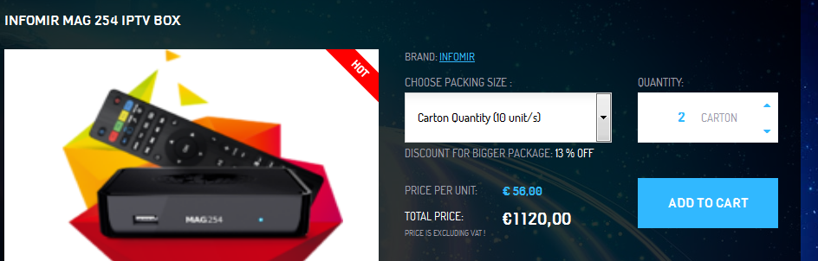
You can easily pair carton quantities and unit quantities of different or same items.
Once you have your order completed you can choose one of options below :
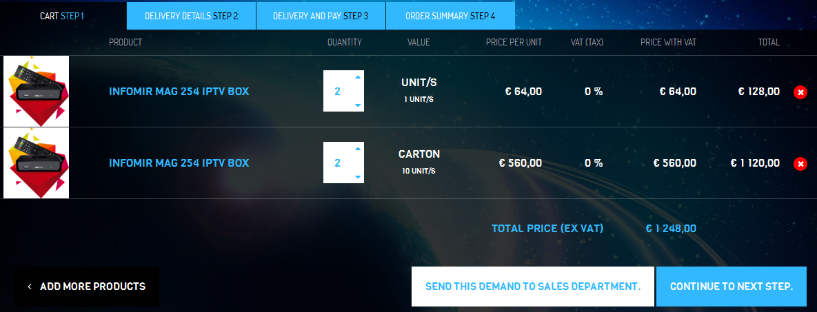
- Send your cart (demand) to sales department so our team can check if is possible to do something with price for transport and so on. (using by outside EU customers mainly)
- Continue to next step with registration or without registration.

In every case you have to fill in few fields. If you are a customer from EU , you have to also input your EU VAT number and choose country where are you from. If is all ok, our program confirm your data in 5 seconds and you could continue on next step - Payment and Shiping.
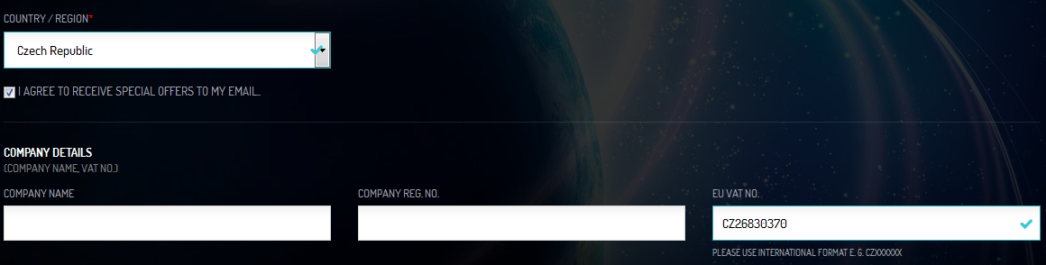

In payment and shiping you will see every possible ways of both categories and also fees. Generaly fees are calculated only in case that payment provider counting any fees for transfer.
If you choose bank transfer, please note that we have to receive full value without any bank fees on any side.
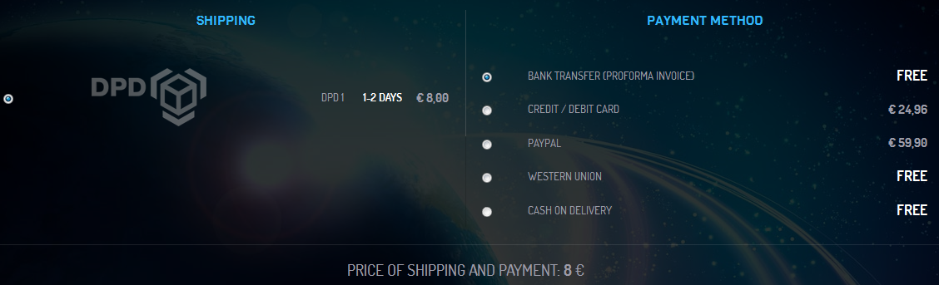
After you completed every steps, you just need to click on Finish the order and our team will contact you as soon as possible. (generaly in next 3 hours)
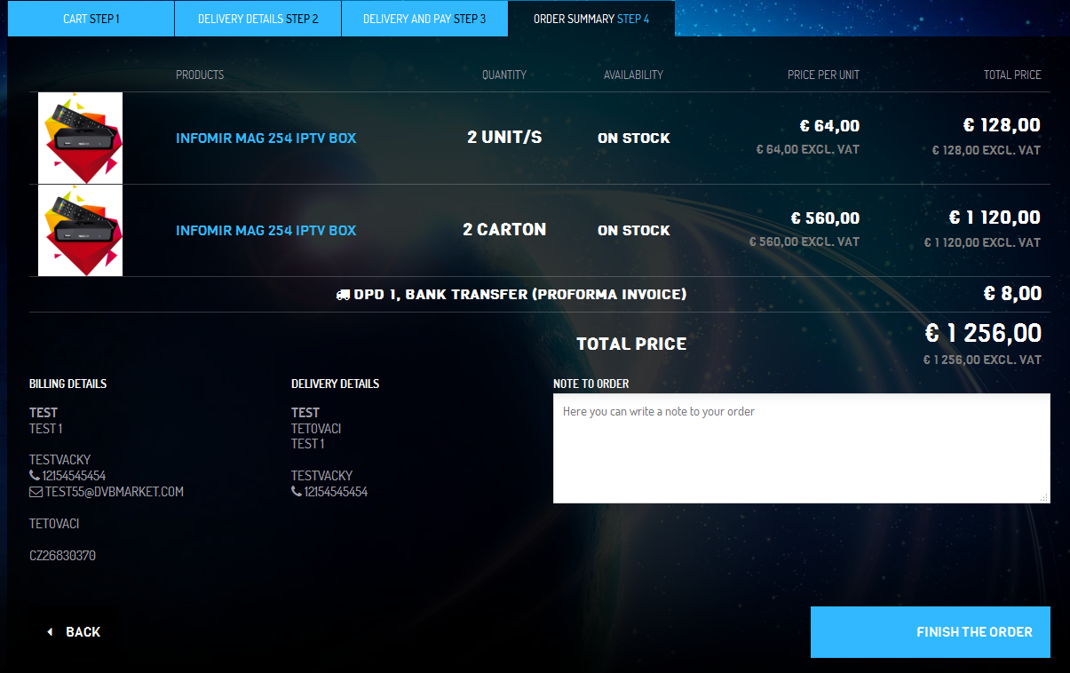
Thank you ! We are growing together !

